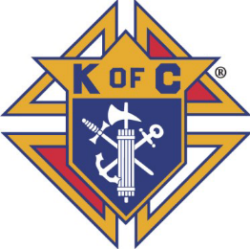

NEWS &VIEWS
www.Knights4698.org August 2019

Grand Knight’s Thoughts

I hope that everyone is enjoying their summer! Although we have not had a lot of activities this past month, there has been planning behind the scenes. A number of members have stepped up to Chair committee’s and plan event’s for later in our fraternal year. THANK YOU!!!

We had another successful Pro Labore Dei (PLD) on July 20 as (28) brothers and family members joined to make another (300) lunches. They were able to complete this feat in about (70) minutes! Thank you to Nick, Tim and the team of volunteers who help make this a special few hours for people who are less fortunate. We also had a much smaller contingency ☹ help Fr. Tom @ St. Stephen planting flowers on (7/27). Thank you Mike & Greg! We also started a new program, headed by our most recent PGK Bill Krueger, called “Share Your Talent”. It is meant to track member’s skills who may be able to help other members. There will be more to follow as Bill builds this program. Finally, during the month of July, our Trustees completed their review of the previous six months (Jan – June) records. Thank you – Trustees and thank you to Dave Whitaker and Bill Bric for your tireless efforts in keeping our records clean and orderly.

As we move into August, activities for our Council will begin in earnest. Our picnic is set for Sunday, August 18. Our picnic Chair is Nick Carone (nick.carone@yahoo.com). The picnic, as in years past, will be at St George in the back of the school. We will have access to O’Connell Hall to provide shad and relief. Please bring a dish to share. We will have adult (Bean Bag Tournament) and children’s games. See our picnic flyer included in this newsletter.

August is also the beginning of our involvement in the ID Drive. This is a year round program that finds our Council heavily involved in the Fall. Last year, the revenue collected represented just under 40% of our budget. For many, many years Eric Holmquest has lead the Council’s participation in this program. This year Eric and Ken Karczewski are mentoring new leaders to continue our involvement in this great program! Tim Sajewski (timsy68@gmail.com) is leading the Church tootsie roll bank drive. Ed Bidrowski (edbidrow@hotmail.com) is leading the Street Drive (9/20 – 9/22) and Joe Siuda (siudaj49@gmail.com) is coordinating both components. Please contact them to see how you can help. Frank Piacenti will be coordinating our concert sales. The first concert is Saturday, August 3. We are also fortunate to have the State ID Chair, Ted Glaser, as a member of our Council.

The Church Bank Drives are as follows:
- St. George Church – 8/3 – 8/4
- St. Julie Church – 8/17 – 8/18
- St Stephen Church – 8/24 – 8/25
- St Damian and St Elizabeth Seton – 8/31 – 9/1

Thank each of you for your Charity, Unity, Fraternity and Patriotism! We should be ready to assist anyone with a new idea or better way to give service to others. As you’ve heard from many of our Brothers – our Council’s strength comes from each one of our efforts.

IF EVERY ONE DOES A LITTLE, NO ONE DOES IT ALL.

Vivat Jesus
Fraternally
John Concannon - Grand Knight

Chaplain’s Message
From the chaplain: As we enter the last month of the summer, plan to attend the Picnic with your family. Family activities are an important part of our fraternal organization's plans to benefit You and Your Family. With the big Marian feast in August, let each member rededicate themselves to praying the Rosary. Prayer is one of our Most Important gifts we bring to our council and our Faith. With prayer all things are possible and when we pray with faith we can indeed change our world. Support your new leadership team. We elected them now give them your support. Offer new ideas but the most beautiful words are "How can I help!" With your presence at our meetings, picnic, fund raisers, fun raisers we will have a grand ole time this year. VIVAT JESUS FR JERRY.

Upcoming Events

August 8/1 No Meeting

8/3 – 8/4 – Tootsie Roll Bank Drive – St. George Church

8/8 Officers Meeting – 8:00 PM – O’Connell Hall

8/15 Regular Meeting - 8:00 PM – O’Connell Hall

8/18 Annual Picnic – St. George – Noon (Setup @ 9:00)

8/17 – 8/18 – Tootsie Roll Bank Drive – St. Julie Church

8/24 – 8/25 – Tootsie Roll Bank Drive – St. Stephen Church

8/31 – 9/1 – Tootsie Roll Bank Drive – St Damian Church

8/31 – 9/1 – Tootsie Roll Bank Drive – St. Elizabeth Seton Church

September 9/5 Regular Meeting – 8:00 PM – O’Connell Hall

9/12 Officer’s Meeting – 8:00 PM – O’Connell Hall

9/19 Regular Meeting – 8:00 PM – O’Connell Hall

9/20 – 9/22 – I D Street Drive

Recent Events

Pro Labore Dei (July 20) @ St. Damian
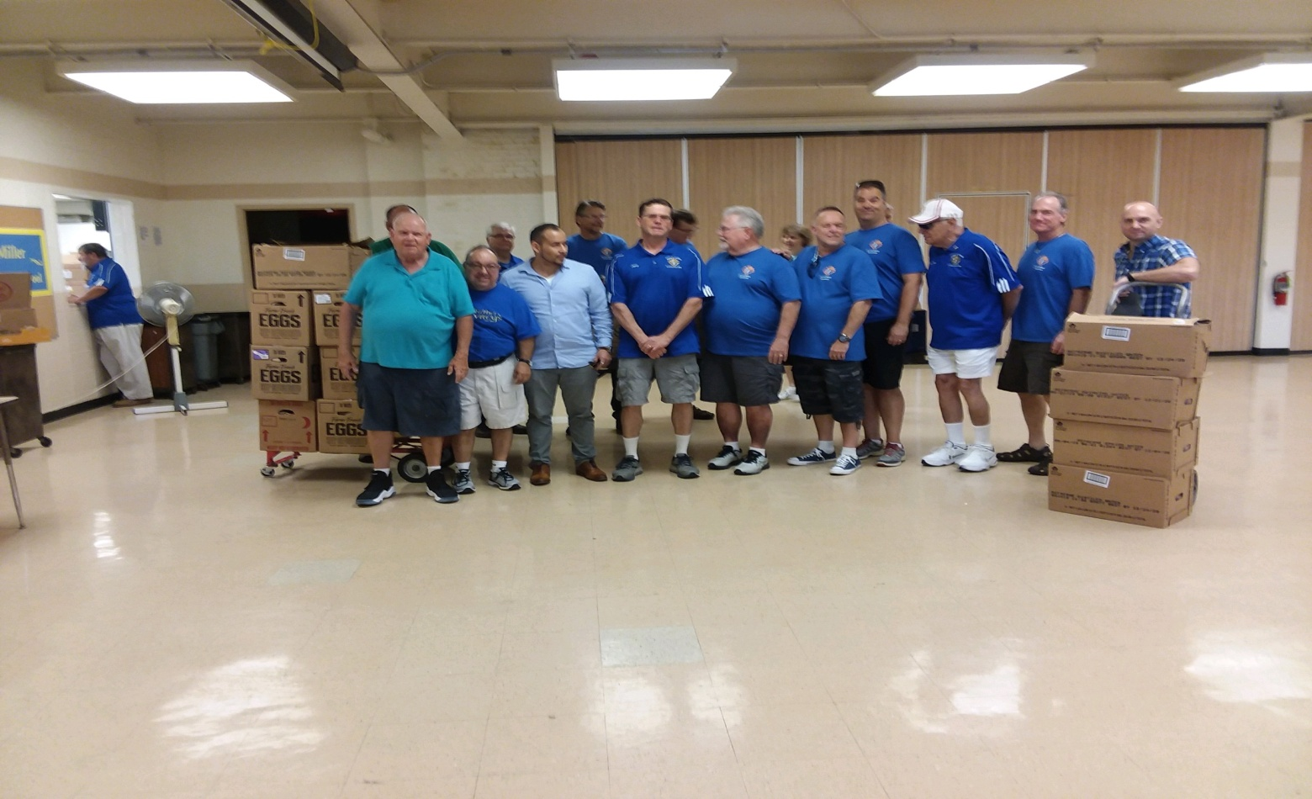

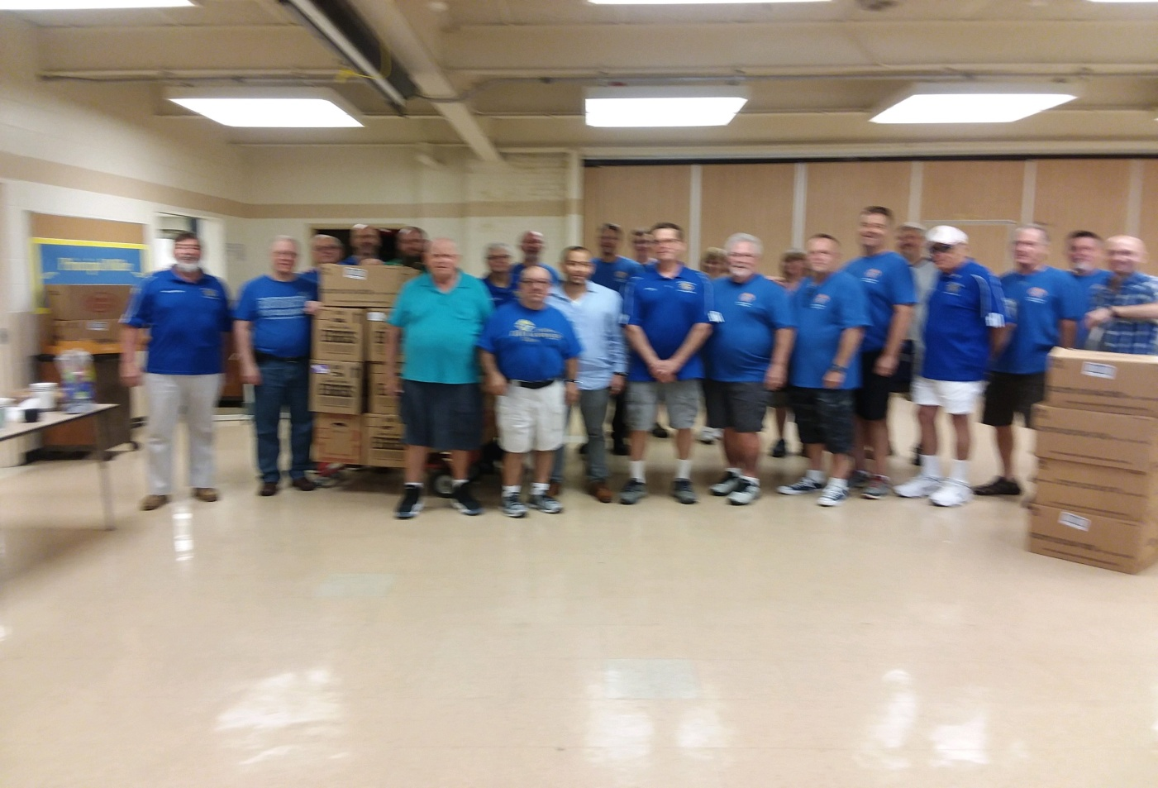

TP Police Car Before Race (Special Olympics)

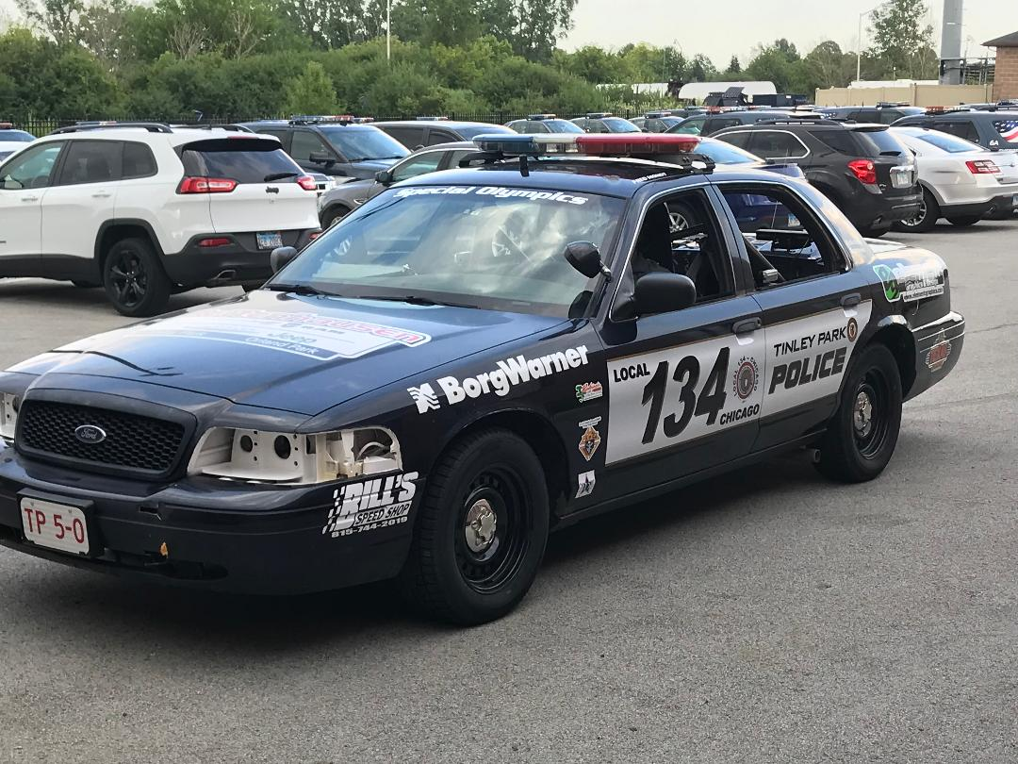

Council Picnic @ St. George – Sunday August 18 Noon – 5:00



