

[www.Knights4698.org](http://www.Knights4698.org) January 2019

HAPPY NEW YEAR !!

We had a great December:

Dec. 1st Keep Christ in Christmas Billboards came to life.

Dec.2nd Advent Began.

Dec. 3rd, We made military packages at St. Julie Parish for our servicemen and women.

Dec.6th, We had our Christmas party beginning with a Mass and gathered a generous donation of baby items.

Dec. 8th, We made sandwiches at St. Damian Parish for Pro Labore-Dei and delivered them to Robbins for distribution to the poor.

Dec. 22nd, We again made sandwiches at St. Damian Parish for Robbins.

January will be busy as well! Please see the Upcoming Events

This is my favorite time of year and is for many, particularly because we get to see some seasonal shows. It may be ***The Sound of Music***, **or *It’s a Wonderful Life*** or how about ***A Christmas Story***, Charlie Brown even pops up around this time. One of my favorites is ***The Polar Express***. Why?

Like the boy in the movie, that can’t hear the sound coming from Santa’s jingle bells until he BELIEVES, we as Catholic men can help others BELIEVE in our Lord & Savior. We must be like Santa’s elves and do our best to show others that it isn’t enough “being good all year”..…That doesn’t allow you to receive the real gift …...To Hear God’s Word, you must BELIEVE!

January 1 begins our officers’ second half of the Fraternal year. These men have been a valuable team with the best interest of our council at the forefront of every decision and discussion. We’ve had a very energetic 6 months, all the events, degrees, gatherings, have been well attended and more importantly well supported by many Brother Knights.

Thank each of you for your, Charity, Unity, Fraternity and Patriotism!

We should always be ready to assist anyone with a new idea or better way to give service to others. As you’ve heard from many of our Brothers, our Council’s strength comes from each and every one of our efforts.

IF EVERY **ONE** DOES A LITTLE, NO **ONE** DOES IT ALL.

Merry Christmas and Keep Christ in Christmas

Happy and Healthy New Year

Vivat Jesus

Respectfully,

Bill K. Grand Knight

Chaplain’s Message

Greetings from your Chaplain,

Our Supreme Chaplain, Archbishop Lori, invites us to imitate Mary and her HASTE in rushing to the side of her cousin Elizabeth who the angel told her was in the sixth month. We must never allow delay to be part of our Council’s work and deeds.

The needs we address and support so important and especially to those who are waiting and don’t know if help is on the way. Let us always look for ways to aid our Church and local community. Share your ideas. Share your time and talent.

Let everyone know the KNIGHTS are here and serving and strengthening our Catholic Faith by our concern for ALL members of our community. When they “see the Christians, How they love one another” it may lead the Unchurched to find Christ in the Catholic Church.

This is one way to be missionaries and spread the GOOD NEWS. May the Infant of Christmas SMILE on US and all we do.

VIVAT JESUS

Upcoming Events

January 1/3 Meeting – 8:00 PM – O’Connell Hall

1/10 Officers Meeting – 8:00 PM – O’Connell Hall

1/12 Past Grand Knight Party – 6:00 PM – O’Connell

Hall

1/17 Blood Drive – 4:00 PM – St. Damian

1/17 Meeting & Admission Degree– 8:00 PM – O’Connell Hall

1/27 Free Throw Contest – 5:00 PM – St. Elizabeth Seton

February 2/2 Membership Drive – 5:00 PM - St. Elizabeth

Seton

2/3 Membership Drive – 7:15–11:30 AM - St. E. Seton

2/7 Meeting – 8:00 PM – O’Connell Hall

2/9 Comedy Night - 6:00 PM – O’Connell Hall

2/14 Officers Meeting – 8:00 PM – O’Connell Hall

2/21 No Meeting –

ID Dinner/Check Presentation 6:00 PM –

O’Connell Hall

Recent Council Events

Billboards Carry Our Message To The World

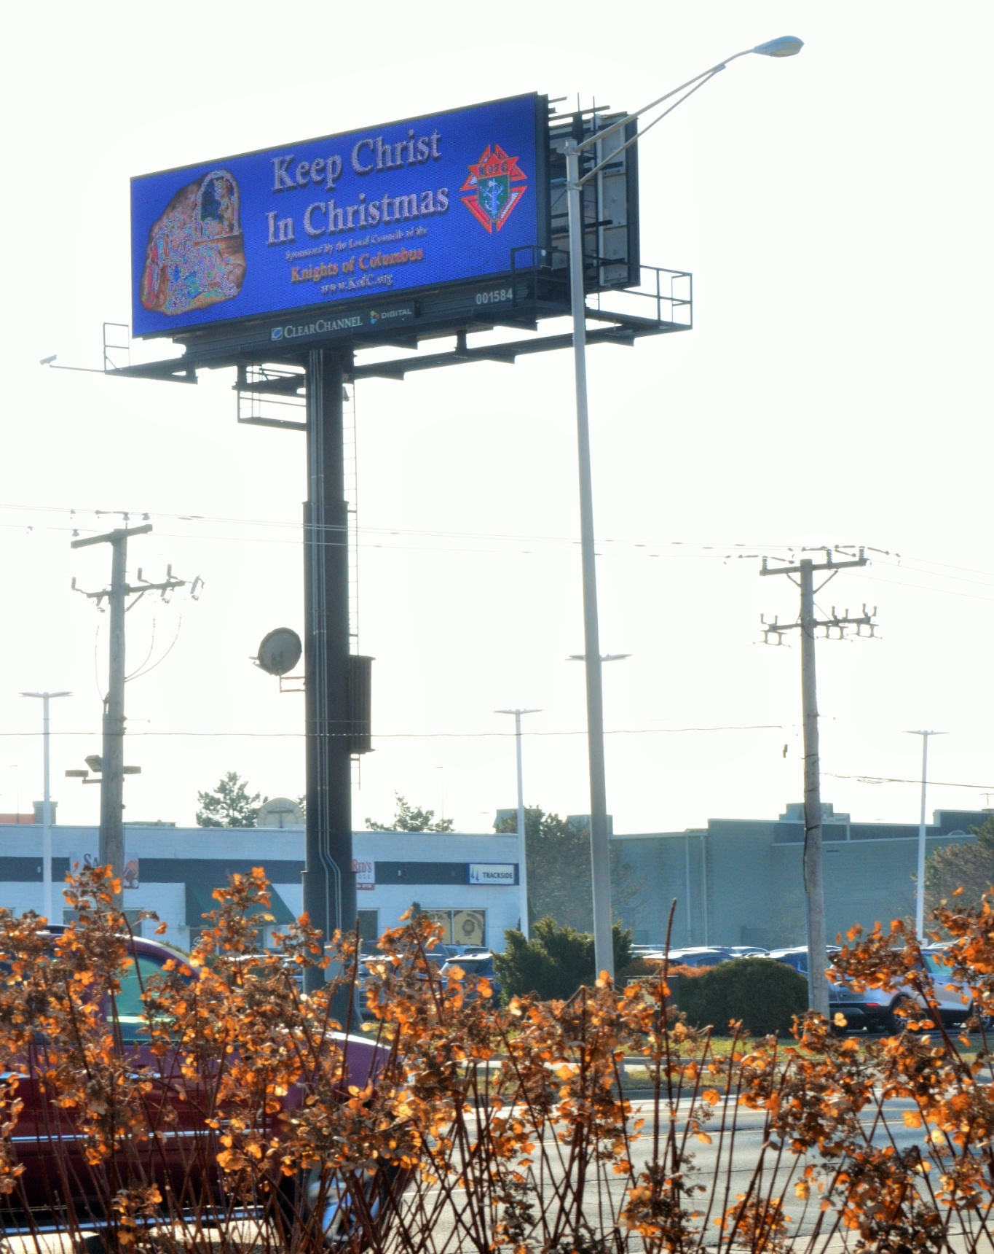

Military Packages at St. Julie

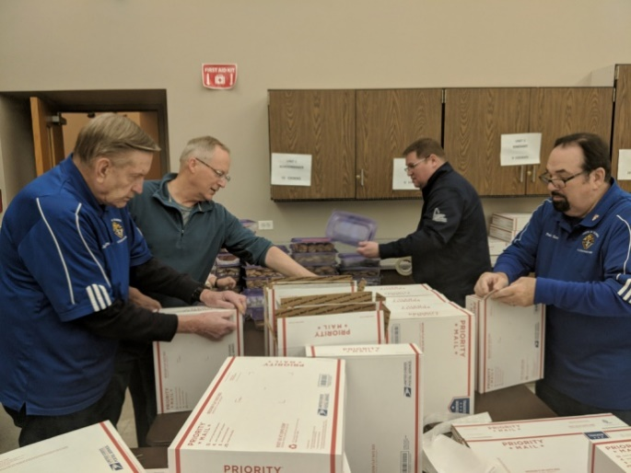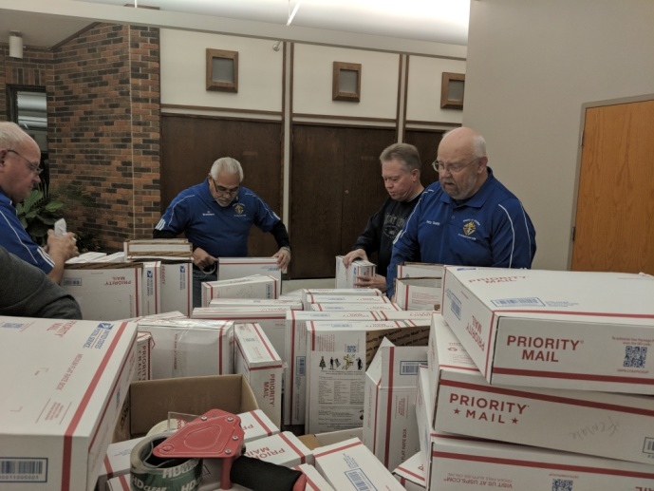

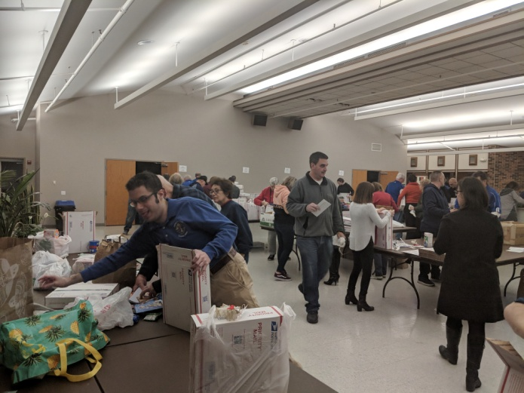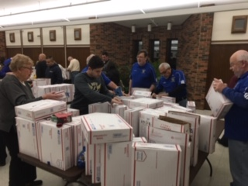

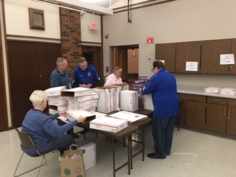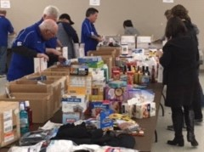

Christmas Mass and Party at St. George

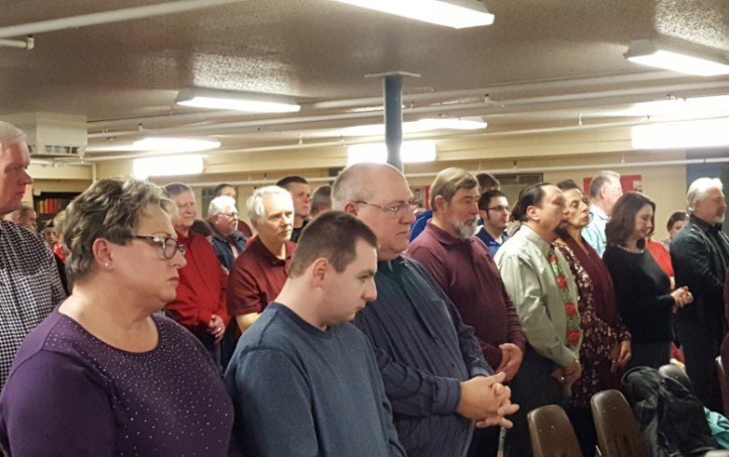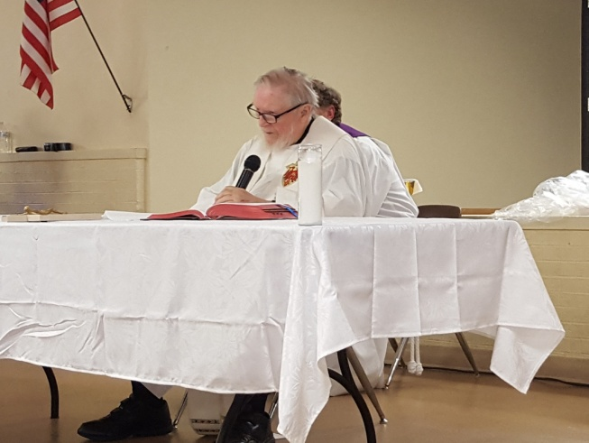

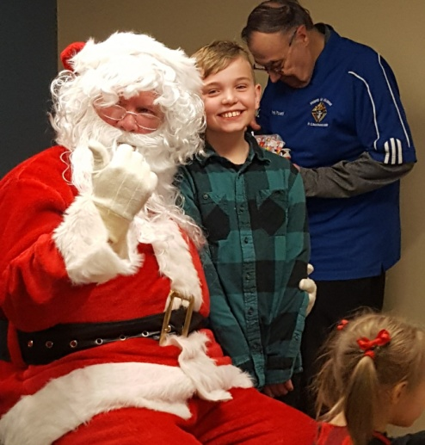 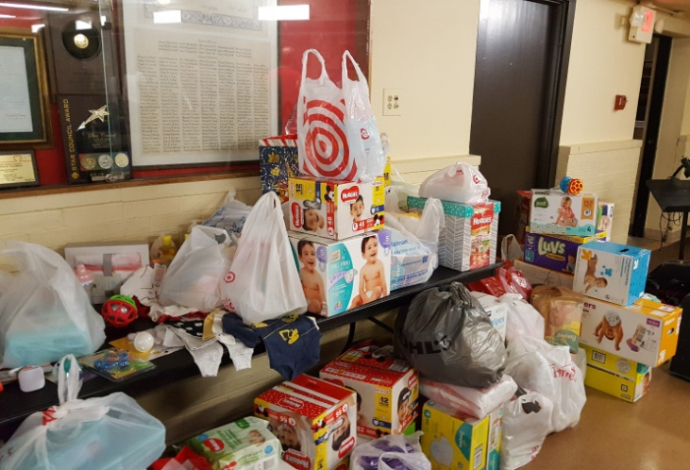

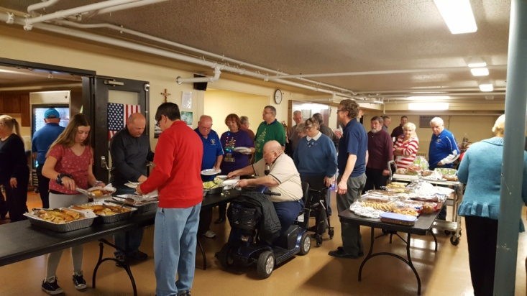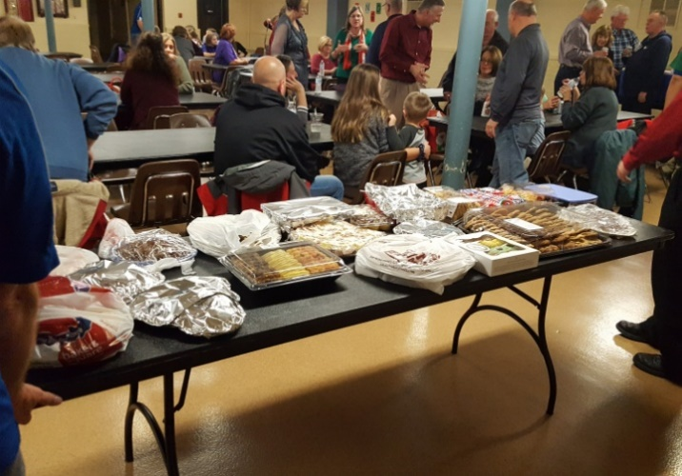

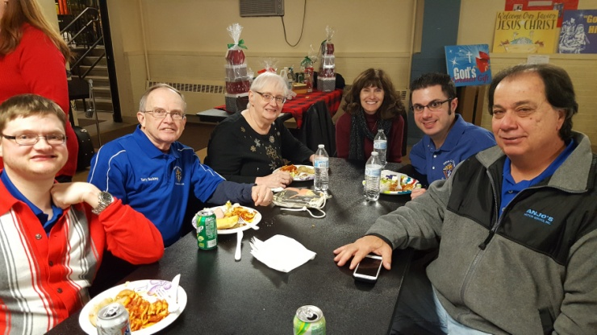More Christmas Party

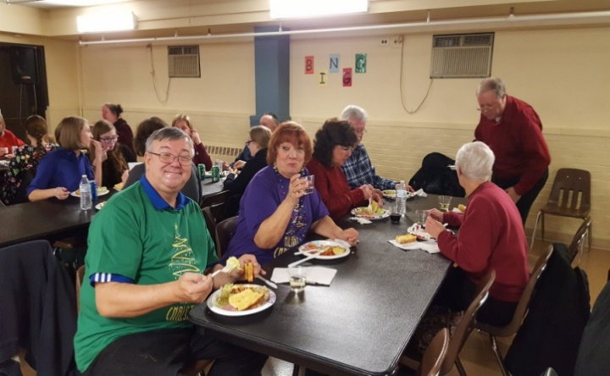

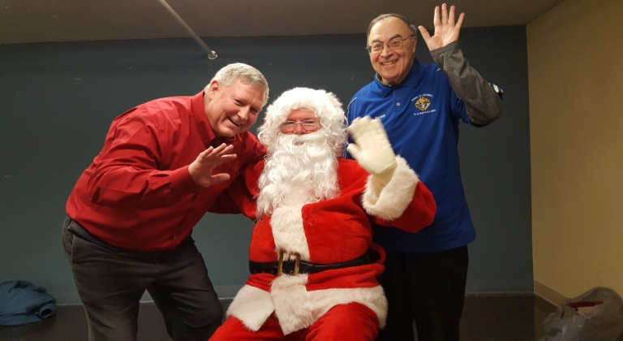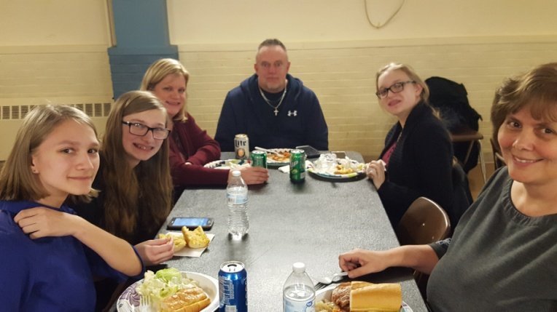

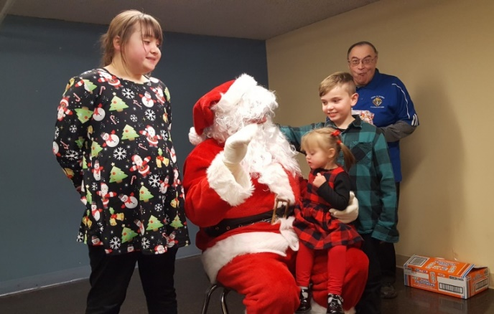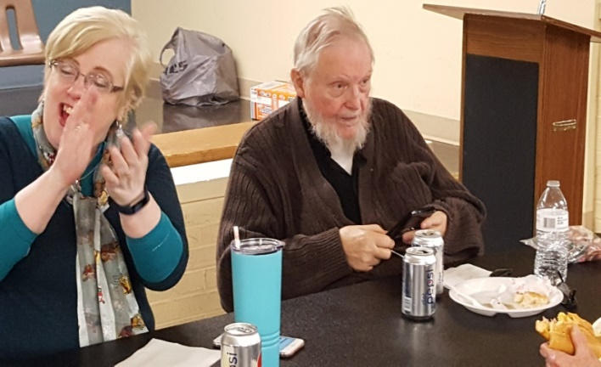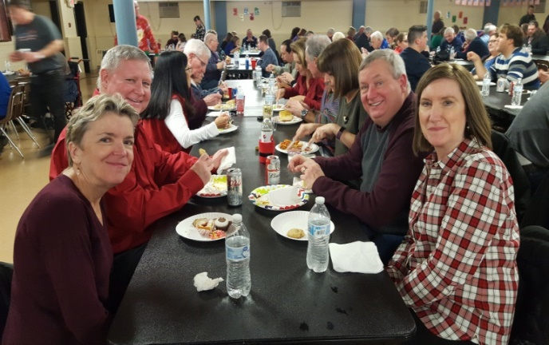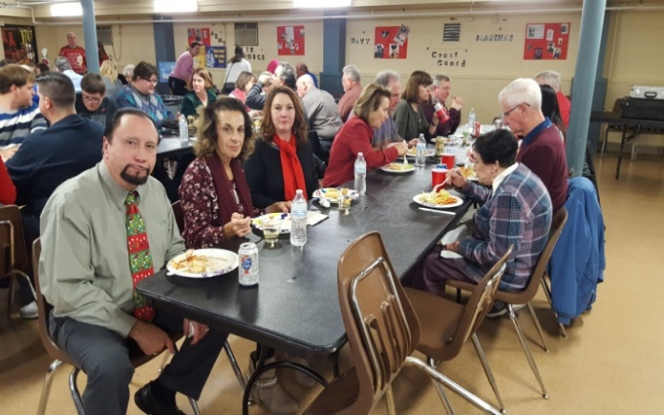

Pro Labore Dei at St. Damian (12/8/18)

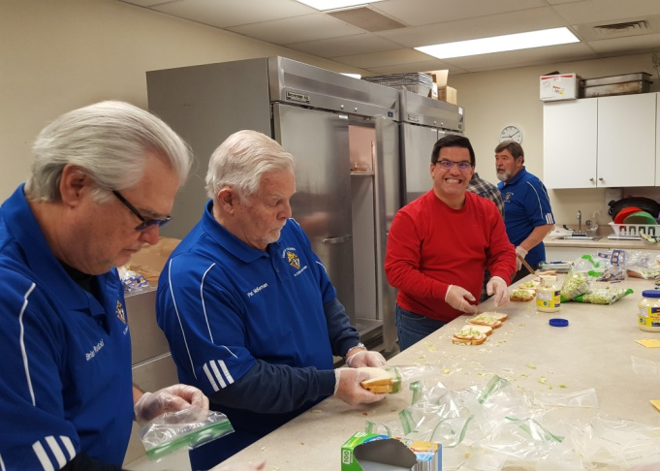

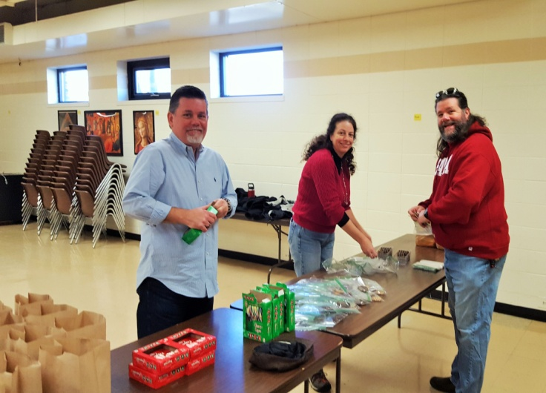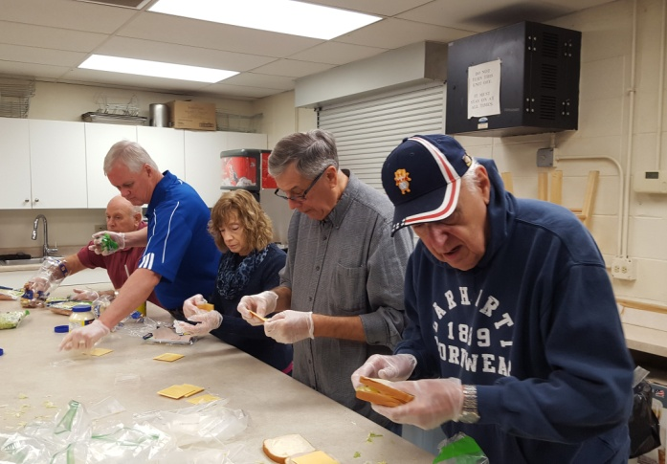

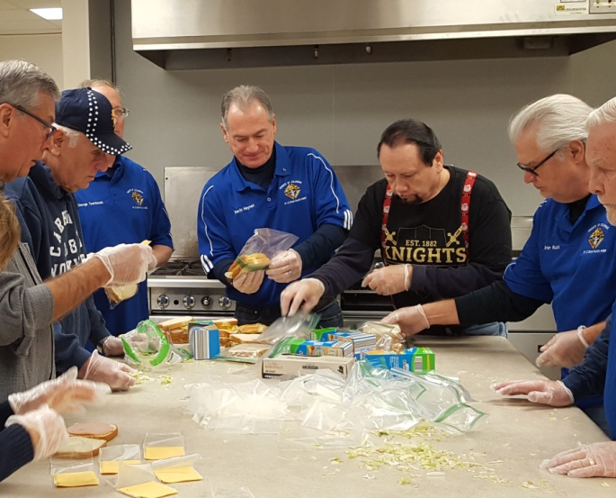 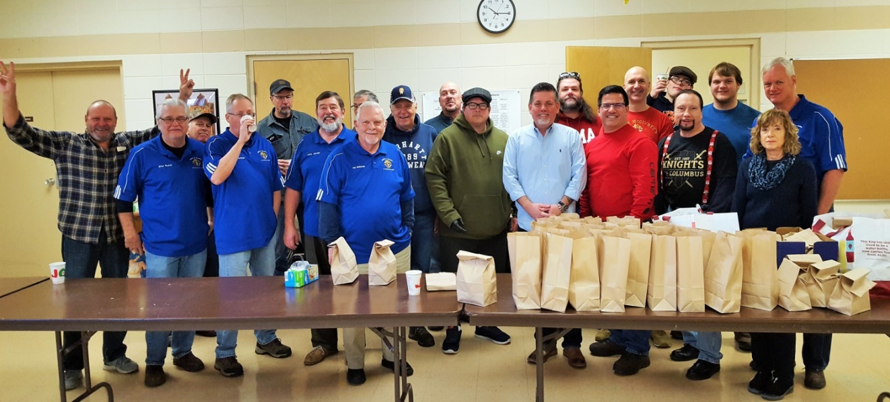

Pro Labore Dei at St. Damian (12/22/18)

